**Humidity sensor-controlled bathroom exhaust fan**

**DIY TEAM 5:**

* **ANISH ROY 21MI100009**
* **DIVYANSHU SINGH 21MI31012**
* **KANIKA GULERIA 21MT30011**
* **SOUMILI MUKHERJEE 21MT10054**

**INTRODUCTION**

We have often seen that the accumulation of moisture occurs in a closed-up space like a bathroom. This can lead to the appearance of mould, which can cause several health issues.

Thus, our project is designed to sense the humidity level in a bathroom and ventilate it until the wet floor dries up to minimize the build-up of humidity in the enclosed space.

**MATERIALS REQUIRED**

* **Casing Fan**

A **computer fan** is any fan inside, or attached to, a com used for active cooling. Fans are used to draw cooler air into the case from the outside, expel warm air from inside and move air across a heat sink to cool a particular component.

* **Arduino Uno R3**

The Arduino Uno is a microcontroller board based on the ATmega328. It has 20 digital input/output pins (of which 6 can be used as PWM outputs and 6 can be used as analog inputs), a 16 MHz resonator, a USB connection, a power jack, an in-circuit system programming (ICSP) header, and a reset button.

* **Temp and humidity sensor**

DHT11 Temperature & Humidity Sensor features a temperature & humidity sensor complex with a calibrated digital signal output. By using the exclusive digital-signal-acquisition technique and temperature & humidity sensing technology, it ensures high reliability and excellent long-term stability

* **Jumper wires**

A **jump wire** is an electrical wire or group of them in a cable, with a connector or pin at each end, which is normally used to interconnect the components of a breadboard or other prototype or test circuit, internally or with other equipment or components, without soldering

* **NPN Transistor**

Transistor allows you to control a circuit that’s carrying higher current and voltage from the lower voltage and current.

**TECHNICAL SPECIFICATIONS OF DHT11 SENSER**

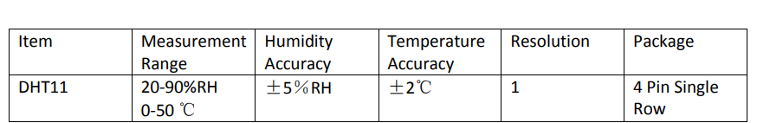

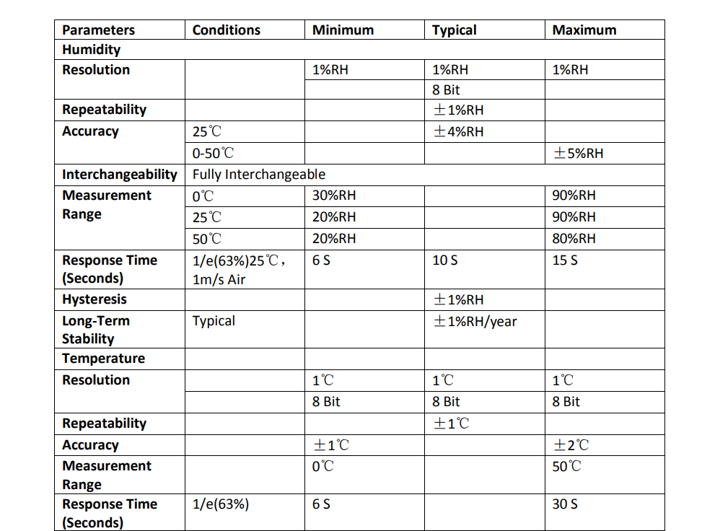

SOURCE: GOOGLE

**WORKING:**

For our project, we have used the DHT11 humidity and temperature sensor, which senses the humidity in air and accordingly sends signals to the motor of the electric fan. These signals regulate the working of the fan.

**CODE:**

#include <DHT.h>

#include <DHT_U.h>

#define dht_apin 12

DHT dht(12,DHT11) ;

float k;

void setup()

{

Serial.begin(9600);

Serial.print ("Group 5");

delay (1000);

Serial.println();

Serial.print("Lets start");

delay (2000);

Serial.println();

}

void loop()

{

k= dht.readHumidity();

Serial.print ("Recording ");

Serial.print ("Humidity");

delay(3000);

Serial.println();

Serial.print ("Humidity= ");

if(isnan(k))

{

Serial.print ("no value recieved");

}

else

{

Serial.print (k);

}

Serial.println();

delay (3000 );

if(k<=40)

{

analogWrite (9,0);

Serial.print("Fan off");

delay(2000);

}

else if(k<=55)

{

analogWrite (9,51);

Serial.print("Fan speed= 40%");

delay(2000);

}

else if(k<=65)

{

analogWrite (9,102);

Serial.print("Fan speed= 60%");

delay(2000);

}

else if(k<=75)

{

analogWrite (9,183);

Serial.print("Fan speed= 80%");

delay(2000);

}

else

{

analogWrite (9,255);

Serial.print("Fan speed= 100%");

delay(2000);

}

Serial.println();

Serial.println();

}

WE ALSO HAVE THE CODE WHICH WOULD BE USED IF WE HAD A PROPER WORKING LCD SCREEN. WE WILL ATTACH THAT CODE WITH OUR PRESENTATION.

**OBSERVATION TABLE:**

|  |  |
| --- | --- |
| HUMIDITY | FAN SPEED |
| 43.7% | 40% |
| 68.02% | 80% |
| 73.71% | 80% |
| 68.44% | 80% |
| 39.01% | FAN OFF |

FOR REFERRING TO SPEED OF FAN IN analogWrite() command we have used 255 as 100%.

This is because analogWrite(255) means a signal of 100% duty cycle. On Arduino Uno, the PWM pins are 3, 5, 6, 9, 10 and 11.

So we have used pin no 9 for our fan.

**CONCLUSION:**

We hope we were successfully able to make the humidity sensor exhaust fan. Through this project we were able to learn the working of various electronic components.

We were able to learn about DHT 11 Humidity sensor and it’s uses as well as synchronization of motor with Arduino.

The cost required for our project setup was RS: 1025.

On surfing through Amazon we found certain humidity sensor based fan with a cost of around 4k-5k.

<https://www.amazon.in/Leviton-IPHS5-1LW-Humidity-Sensor-Control/dp/B00H3QQD64>

Thus we suppose our project is much cheaper and solves the purpose quite efficiently.